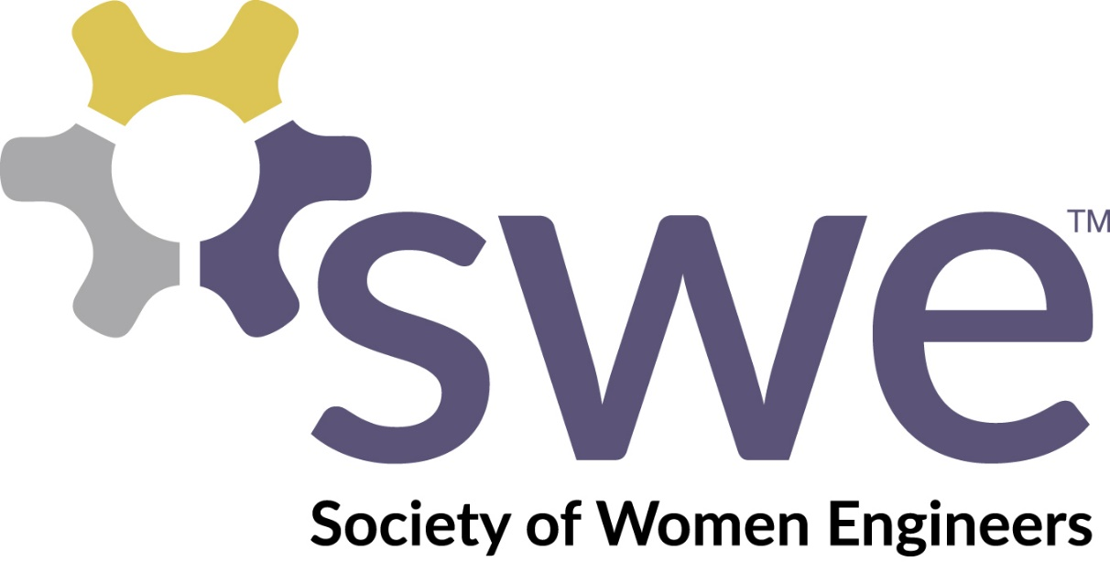

University of Nevada, Reno
Corporate Sponsorship Package
2015-2016

Dear Company Representative,

The University of Nevada, Reno’s Society of Women Engineers (SWE) invites you to be part of our ever-expanding community. Members of SWE have the opportunity to attend workshops and meetings which encourage valuable networking and support for future women engineers. SWE members are also able to attend or facilitate outreach activities within the community. They are given the opportunity to attend social and networking events that provide the critical exposure in the engineering industry.

As you will find listed below, we offer many of the aforementioned events throughout the year. In particular, we would like to offer you the opportunity to sponsor Evening with Industry (EWI), one of the most premier events held on the University of Nevada, Reno’s campus.
In this packet, you have the option of choosing an amount of sponsorship under any of the following categories. We believe that this partnership will allow you, as a company, to be more visible to the University of Nevada’s ever-expanding population and offer you connections with the next generation of bright and innovative engineers.

On behalf of all SWE members at the University of Nevada Reno, we thank you for your interest in partnering with us. We hope to work with you in the future and make you part of our innovative and aspiring group of future women engineers. For more information, email me at swe.unr@gmail.com.

Sincerely,

Rachel Lucas
President of the Society of Women Engineers
Section A056 - University of Nevada, Reno

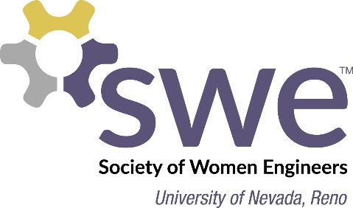

Sponsorship Opportunities

General Donation - $25 - $1,000
The Society of Women Engineers at the University of Nevada, Reno is a non-profit organization centered on inspiring future generations and giving our members confidence and resources towards attaining their dream career. Give to this country’s future engineers that are going to provide a high quality workforce and diversify economic growth for our city, state and nation. With this gift, your company would be recognized as a key sponsor on our website as well as during one of our largest events, Evening with Industry. Your sponsorship will contribute to the following causes and other activities put on throughout the year by SWE:
- Information Session or Workshop
Come let our students know what your company has to offer, or connect with students through an interactive workshop on a topic of your choice. Choose the date and time, and we will reserve a room, provide a projector, and advertise on campus. Please contact us at swe.unr@gmail.com if you are interested in hosting an informational session through our section.

- Outreach Events
Your sponsorship will allow our section of the Society of Women Engineers to engage students in K-12 through outreach in the Reno community. We organize fun and simple engineering activities to get students interested in engineering.

- SWE National Conference
The most important trip on the SWE calendar is the annual National SWE Conference, which is typically held in October. National Conference brings together businesses, organizations and universities under the premise of encouraging innovative engineering. Through your sponsorship, conference attendance for UNR SWE members directly will allow us to participate in an event that past members consider invaluable.

Gift Payment Information
Total Amount Enclosed: $______________ Please make checks out to “SWE UNR Foundation.”

Mail to: University of Nevada, Reno, MS 0260
Electrical and Biomedical Engineering Dept. SWE-EWI Reno, NV 89557
- Or –
Give online at unr.swe.org/sponsorship

